Switched Mode Power Supply

A **switched-mode power supply** (**switching-mode power supply**, **SMPS**, or **switcher**) is an electronic power supply that incorporates a switching regulator to convert electrical power efficiently.

Unlike a linear power supply, the pass transistor of a switching-mode supply continually switches between low-dissipation, full-on and full-off states, and spends very little time in the high dissipation transitions, which minimizes wasted energy. Ideally, a switched-mode power supply dissipates no power. Voltage regulation is achieved by varying the ratio of on-to-off time. In contrast, a linear power supply regulates the output voltage by continually dissipating power in the pass transistor.

This higher power conversion efficiency is an important advantage of a switched-mode power supply. Switched-mode power supplies may also be substantially smaller and lighter than a linear supply due to the smaller transformer size and weight.

**Working Principal**

A linear regulator provides the desired output voltage by dissipating excess power in ohmic losses (e.g., in a resistor or in the collector–emitter region of a pass transistor in its active mode). In contrast, a switched-mode power supply regulates either output voltage or current by switching ideal storage elements, like inductors and capacitors, into and out of different electrical configurations. Ideal switching elements (e.g., transistors operated outside of their active mode) have no resistance when "closed" and carry no current when "open", and so the converters can theoretically operate with 100% efficiency (i.e., all input power is delivered to the load; no power is wasted as dissipated heat).

In an SMPS, the output current flow depends on the input power signal, the storage elements and circuit topologies used, and also on the pattern used (e.g., pulse-width modulation with an adjustable duty cycle) to drive the switching elements. The spectral density of these switching waveforms has energy concentrated at relatively high frequencies. As such, switching transients and ripple introduced onto the output waveforms can be filtered with small LC filters.

# Block view of a SMPS

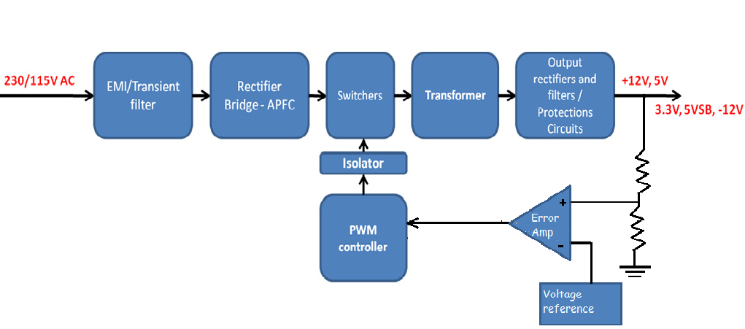

1. EMI/Transient Filter: Suppress incoming and out coming EMI/RFI generated by high frequency electronic circuits and protects from voltage spikes as well. The cause of this EMI is discussed after this block diagram.

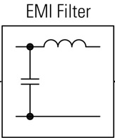 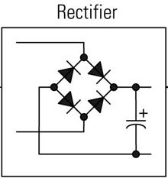

1. 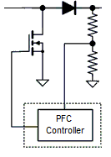Bridge Rectifier: Rectifies the main AC power stream to DC. This essentially forms the primary section of every power supply unit.
2. PFC/APFC: Power factor control unit/ Active power factor control unit this essentially controls the current supplied to the PSU so that the current waveform is proportional to the mains voltage waveform. In DC-DC convertor the output LC coupling introduces a significant phase shift in voltage and current waveforms leading to imbalanced power factor. But typically to regulate the requirements of power factor a power factor control circuitry (PFC) is included as part of a SMPS.

EMI/Transient Filter, bridge rectifier and power factor control unit essentially forms the primary part of a SMPS.

1. Main Switches/Convertor: This plays the pivotal role behind working of every SMPS. It essentially does the DC-DC or DC-AC conversion. Chop the DC signal to very small energy packets, with high frequency. This consists of a load regulator section having a solid state device like BJT or MOSFET for switching constant DC usually driven by PWM controller.

This can broadly categorised in to two categories:

* + 1. DC-DC Convertors (i.e. SMPS)
       - Step down (Buck) Convertors
       - Step up (Boost) Convertors
       - Buck-Boost Convertor (fly back convertor)
       - Cu’k DC-DC Convertor

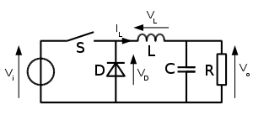 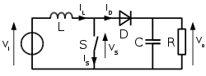

Buck Convertor Boost Convertor

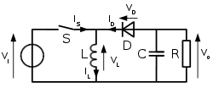 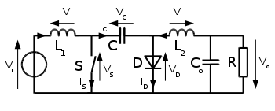

Buck-Boost Convertor Non-Isolated Cu’k Convertor

* + 1. DC-AC Convertors (i.e. invertor, UPS)
       - Sinusoidal DC-AC convertors (Single phase/3-phase invertors)

1. HF Transformer: Isolates primary from secondary side and converts (steps down) the voltage if required.
2. Output Rectifiers & Filters: Generate the DC outputs and filter them. This is essentially second order filter to further smoothen the output voltage ripples.
3. Protection Circuits: Shut down the PSU when something goes wrong. i.e. Sometimes a surge of rapid inrush current/spike of over voltage can damage the load side sensitive electronic circuitry (like motherboard) in order to avoid such damages usually protection circuitry is added to secondary side of SMPS. This consists of surge/spike protection circuits.
4. PWM Controller: Adjusts the duty cycle of the main switches, in order to keep steady output voltage under all loads. This essentially maintains the duty cycle of output PWM high frequency pulsating DC in order to account for variable load impedance and input voltage fluctuations.
5. Isolator: Isolates the voltage feedback that comes from the DC outputs and heads to the PWM controller

The part of the SMPS before the power transformer is called “primary” side and the part after it “secondary” side.

# DC-DC Convertors

# Electromagnetic interference (EMI)

EMI also known as RFI (Radio frequency interference) when lies in RF band this disturbance effects electric circuit. It is caused due to

# References

1. Do
2. <http://www.eejournal.org/journal/20110114164/op-amp-voltage-follower-regulator-spice-model>
3. http://simonthenerd.com/files/smps/SMPSBuck**Design**_031809.pdf‎
4. <http://www.intechopen.com/books/matlab-a-fundamental-tool-for-scientific-computing-and-engineering-applications-volume-1/simulation-of-power-converters-using-matlab-simulink>

# Acknowledgements